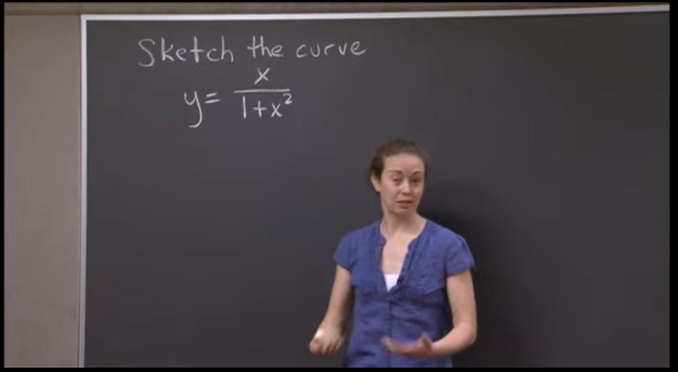

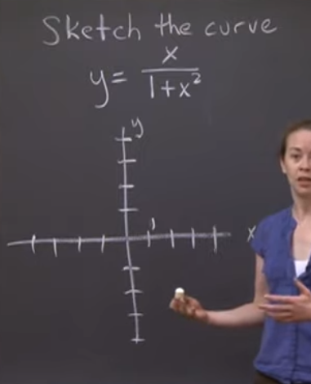

1. Check where the functions will be undefined

* In this case, none because our denominator will always be positive no matter what
  + Evaluate the function to 0 right away f(x) = 0
* No need to add asymptotes for being undefined

1. End behavior/ End points

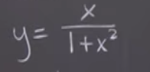

* Denominator will always be the bigger one
* So, this function will always head to 0 on infinities, thus we need a horizontal asymptote

1. Where the sign will change

* In this case, the sign is dependent on our numerator

Getting the derivatives:

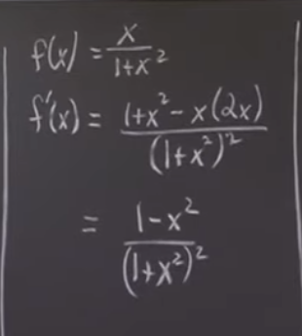

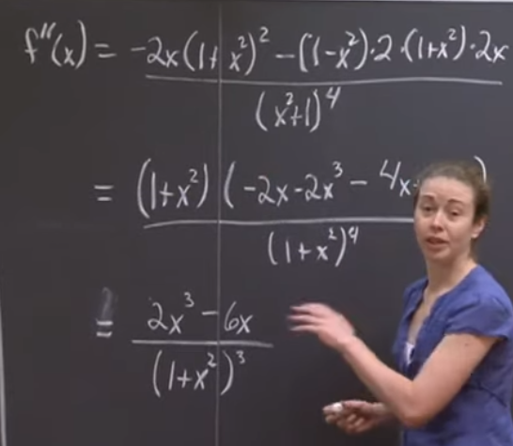

Getting where the derivatives are 0

* 1st derivative = 0 max min
* 2nd derivative = 0 changes in concavity

1st derivative = 0

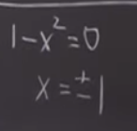

2nd derivative = 0

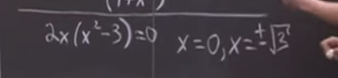

Evaluating f(x) = 0 (if you know that the function is defined in all points

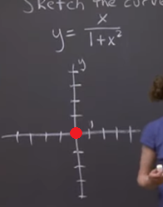

Evaluating f(x) using the max-min

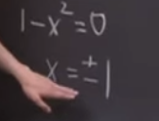

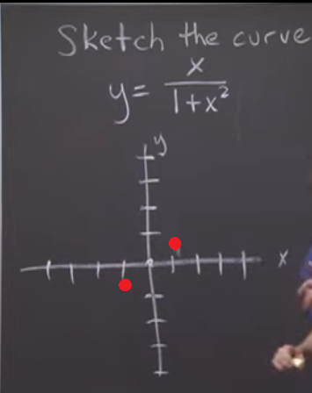s

Rough sketch considering the end behavior (end point infinity)

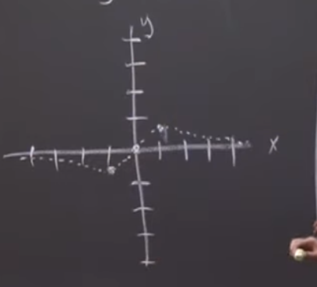

Change in concavities (2nd derivative = 0 results)

